 | 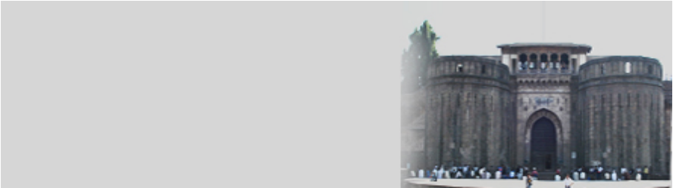  ISEC2009  2nd India Software Engineering  Conference  Pune, Feb 23-26, 2009 | 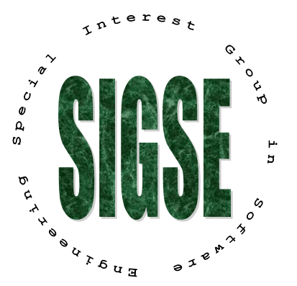

IN COOPERATION WITH   Conference Organization  General Chair  Kiran Deshpande, AirTight  Program Chair  Pankaj Jalote, IIT Delhi  Sriram Rajamani, Microsoft Research, Bangalore  Workshop Chair  T.V.Prabhakar, IIT K  Tutorial Chair  Deepak Gupta, AirTight  Org Committee Chair  Anand Deshpande, Persistent  Our Corporate Series Sponsers            Our Local Sponser   | The 2nd India Software Engineering Conference will be held in, Yashwantrao Chavan Academy of Development Administration (YASHADA), Pune, Feb 23-26. ISEC conference is the main yearly conference of the newly created Special Interest Group on Software Engineering, SIGSE (www.cse.iitd.ac.in/sigse/) of the Computer Society of India. ISEC will bring together researchers and practitioners from across the world to share the results of their work. In ISEC2009 we have technical sessions with research papers.  Technical Sessions  From over 100 submissions received, a compact program of 12 full papers and 14 poster papers in different areas have been selected. The papers were selected by an International Program Committee. Proceedings will be published by ACM, and all papers will be in the ACM digital library.  Experience Report Papers  In this ISEC we have papers in this category to describe state-of-the-art in practice. From many sessions, 6 papers have been accepted by the Program Committee for presentation in the conference.  Special ICSE and FSE Sessions  In cooperation with ACM SIGSOFT, two of the best papers from the flagship conferences FSE (Symposium on Foundations of Software Engg) and two from ICSE (International Conference on Software Engineering) will be presented as Invited papers in special sessions. The papers are:  • What makes a good bug report, N. Bettenburg, et.al. (FSE 2008)  • Efficient online monitoring of Web-Services SLAs, F. Raimondi, et.al. (FSE 2008)  • Debugging reinvented: asking questions and answering about program behavior,  A. Ko and B. Myers (ICSE2008)  • Precise memory leak detection for java software using container, G. Xu, A. Rountev  (ICSE2008)  Keynotes  ISEC2009 will have one keynote from a researcher of international repute, and a keynote from a leader from the Indian IT industry. The keynote speakers are: David Rosenblum, Univ College London, and Vijay Kumar, CTO, Wipro.  Tutorials  There are four tutorials in the conference by various experts:  - Principles of Software Architecture Design, Len Bass, SEI  - A model-driven software factory to support enterprise application product-lines, V Kulkarni, TRDDC, Pune  - Emerging Trends in Software Test Plan Automation, R Gorthi and A Pasala, Infosys  - Software in Manufacturing, Shripad Lale, Performix Solutions, Pune  Workshops  There is one specialized workshop: Software Product Line Evolution Workshop  Registration  Online registration and payment can be done at: www.cse.iitd.ac.in/~sigcse/isec2009  Group Registration Discounts: Group registrations from an organization may get discounts in the form of complimentary registration. If you have three or more people registering, please contact the registration incharge for extra complimentary registrations.  For Indian Academics and Students: If your institution cannot afford this registration fee, if your HOD/Principal sends a mail to this effect, we will waive this reduced fee further by 50%. For extreme situations, a complete waiver may also be possible.
  FEE STRUCTURE | Regular | Indian Faculty | Students
  Main Conference | Rs. 8,000/- | Rs. 4,000/- | Rs. 2,000/-
  Tutorial | Rs. 4,000/- | Rs. 1,500/- | Rs. 1,000/-
  Workshops | Incl. in Conf. fees | Incl. in Conf. fees | Incl. in Conf. fees
  Combo (All Above) | Rs. 12,000/- 10,000/- | Rs. 5,500/- 5,000/- | Rs. 3,000/- 2,500/-

